**8218 - Arsh Nadeem - Introduction to Linux - Jan 2025**

1. Create nested directories

-> using mkdir



**2.** Creating two empty files inside dir2 directory: emptyFile1, emptyFile2 in single command

->using touch command

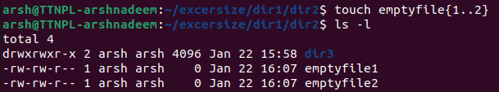

**3.** Creating one file file1.txt containing text "hello world" and saving it.

-> using echo command

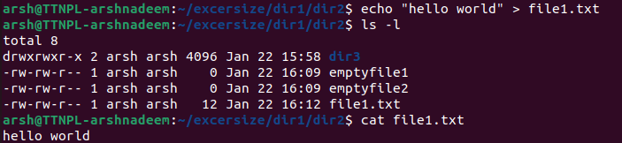

**4.** Finding a "passwd" file using find command inside /etc. Copying these files as passwd_copy and then renaming this file as passwd_backup.

-> using find to find the file

-> using cp to copy the file

-> using mv to rename the file

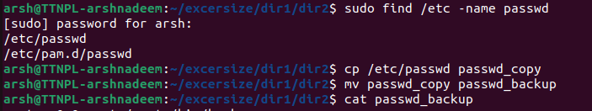

**5.**  Reading passwd_backup file in multiple tools: less,more,cat,strings etc and finding the difference in their usage.

-> cat passwd_backup

-> less passwd_backup

-> more passwd_backup

-> strings passwd_backup

Observed difference :

cat: outputs the entire file to the terminal at once.

less: Allows us to scroll up and down through the file.

more: Similar to less but allows only forward navigation.

strings: filter and display only printable characters.

6. Finding out the number of lines in password_backup containing "/bin/false".

->using grep command



7. Getting the first 5 lines of a file “password_backup” and Redirecting the output of the above commands into file "output". Also, getting the lines 6-10 from the above file.

-> using head for getting the first 5 lines.

-> redirecting the output using ‘>’.

-> getting the lines 6-10 from the above file using sed command

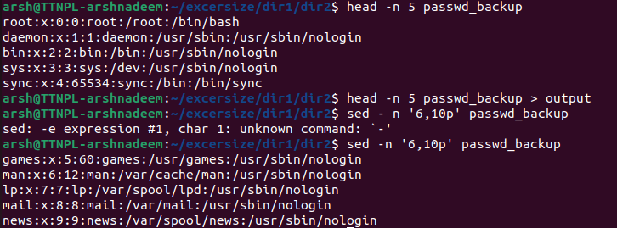

**8.** Creating a "test" user,creating its password and finding out its uId and gId.

-> creating new user using useradd command

-> creating password using passwd command

-> getting uId and gId using id

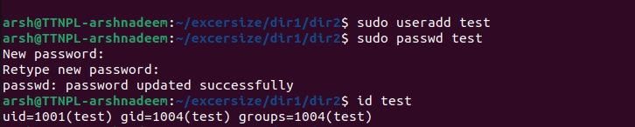

**9.** Changing the timestamps of emptyFile1, emptyFile2 in dir2.

-> using touch command

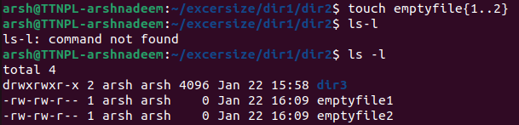

10. Logging as test user and editing the "output" file created above. Since the permission won't allow us to save the changes. Configuring such that the test user can edit it.

->logging as a ‘test’ user and attempting to edit the output file

>switching to the ‘test’ user

>trying to edit the output file

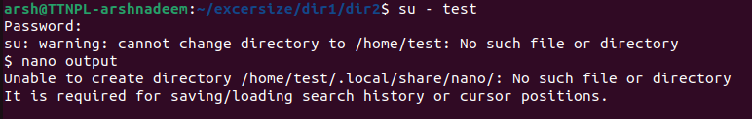

->Granting the ‘test’ user permission to edit the output file



Note: alternate way can be using usermod and -aG. A:append, G: Groups

-> Making the file editable to the world

-> reverting the changes

-> changing ownership.

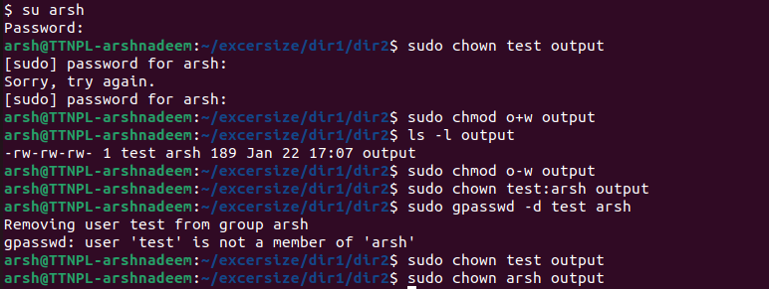

-> using chmod to allow user to edit

-> -rw-rw-rw 1 test arsh …. Indicates 'user 'test’ under group ‘arsh’ can edit output.

-> removing write permission for others using ‘chmod o-w’.

-> reverting ownership to original owner i.e arsh

-> remove the test from the group using gpasswd.

11. Creating an alias with my name so that it creates a file as "/tmp/aliastesting".

-> Defining alias



->testing the alias and verifying the file.



12. Editing ~/.bashrc file such that when I change to "test" user it should clear the screen and print "Welcome".

-> editing the ~/.bashrc file of the test user



-> adding following line

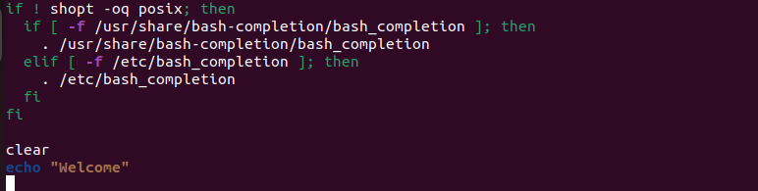

-> saving

-> on switching to test output will be





13. Install “zip” package.

-> using apt update(advance package tool)  
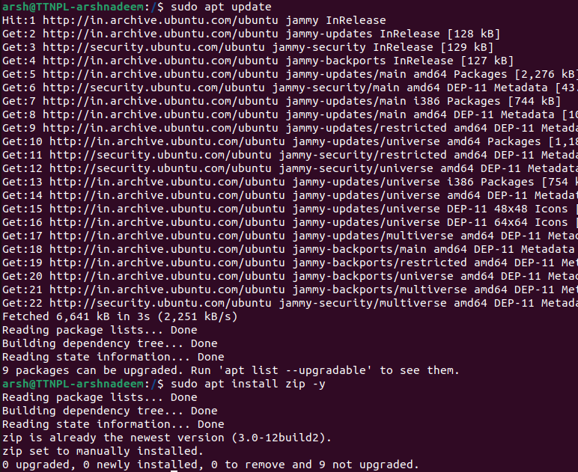

14. Compress "output" and "password_backup" files into a tar ball. List the files present inside the tar created.

-> Compressing the file into Tarball using tar command

> tar command to create an archive

> -c to create a new archive

> -v to show the process(verbose mode)

> -f specify the file name



-> Verifying the tarball creation.

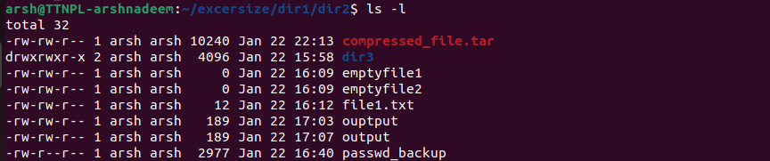

-> listing the file in tarball

> -t : list the content of tarball



15. scp this file to test user

->Ensure test user on home directory

Scp:secure copy command

Compressed_file.tar: file to be copied

test@localhost: on local machine

/home/test/: Destination directory

-> Entering test user password

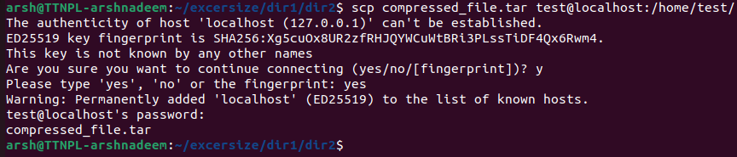

-> verify file transfer

Login test user: su - test



16. Unzip this tar file by logging into the remote server

->logging into remote server where the file was copied using ssh



-> navigating to directory containing Tarball

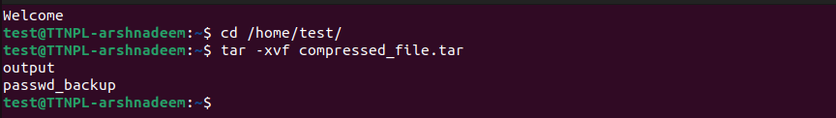

x:Extract files from tarball

-> verify extraction

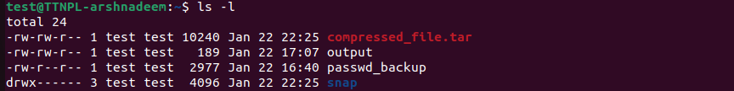

17. Download any image from web and move to desktop

-> using wget command

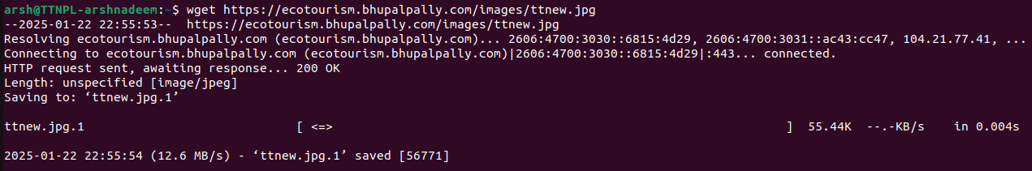

18. How to get help of commands usages.

-> using man

E.g: man ls

-> using --help

E.g: ls - - help

-> using info

E.g: info ls

-> using whatis

E.g: whatis ls ( one line description)

19. Create a symlink of /etc/services into /tmp/ports-info

-> using ln command for creation

-> verifying using ls -l command

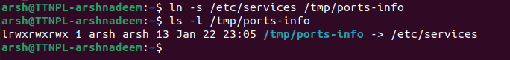

Ln: command to create links

-s: creates a soft link

/etc/services: targeted file we want to link

/tmp/… : location where symlink will be created

L: denotes the symlink

20. You are appointed as a Software/DevOps Engineer in ABC media services. On your first day you need to troubleshoot a problem. There is a command “xyz” somewhere installed in that linux system. But as a new joinee you do not have any idea about where is that Installed. How can you check that?

-> can be done using several methods

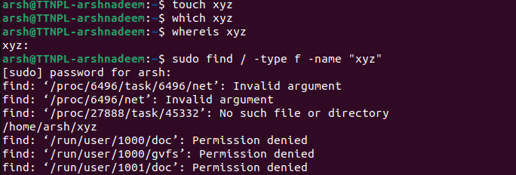

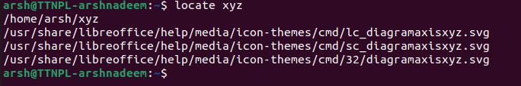

Thank you!